# **Talking Lands Assessment - UI Implementation Spatial Data Mapping Application**

## ****Overview****

This project is a solution to the assessment task provided by Talking Lands. The primary goal is to create an interactive map-based user interface that renders spatial data in various formats (Point, Polygon, and Multipolygon). The application is developed using [React.js/Vue.js], incorporating modern map SDKs and APIs for spatial data visualization.

## ****Features****

### **1. Map Container with Geo Marker Pins**

* Displays multiple point data layers on the map.
* Geo marker pins are placed based on spatial data (latitude and longitude) fetched from a sample API.
* Built using a map SDK/plugin like [Mapbox, Leaflet, or OpenLayers].

### **2. Polygon Layers**

* Renders polygonal shapes on the map using the spatial dataset (Polygon/Multipolygon).
* Each layer is overlaid seamlessly on the map.

### **3. Interactive Map Events**

* Implemented interactive map events like:
  + **Click**: Fetch and display specific spatial feature data in UI cards.
  + **Load**: Display initial map state with all available layers..
* Captures and displays detailed spatial feature information in responsive UI cards.

.

**Technologies Used**

• **Frontend Framework**: [React.js ]

• **Map SDK**: [Mapbox]

• **API Integration**: RESTful API for fetching spatial datasets

**Evidence of Work**

I have included evidence of the completed UI as part of this repository. Please review the following:

* Screenshots of the UI

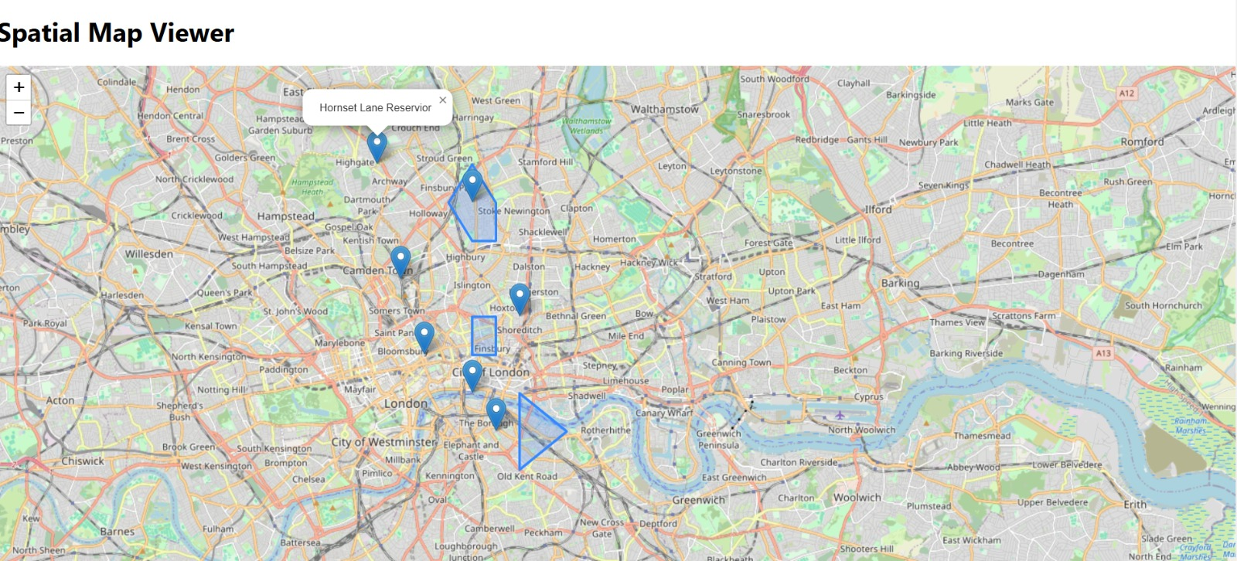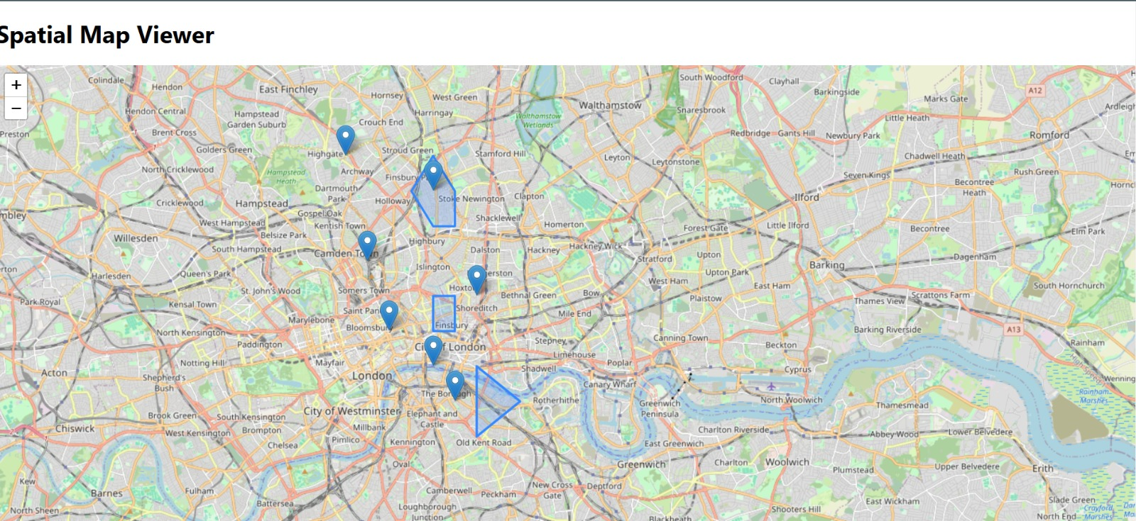

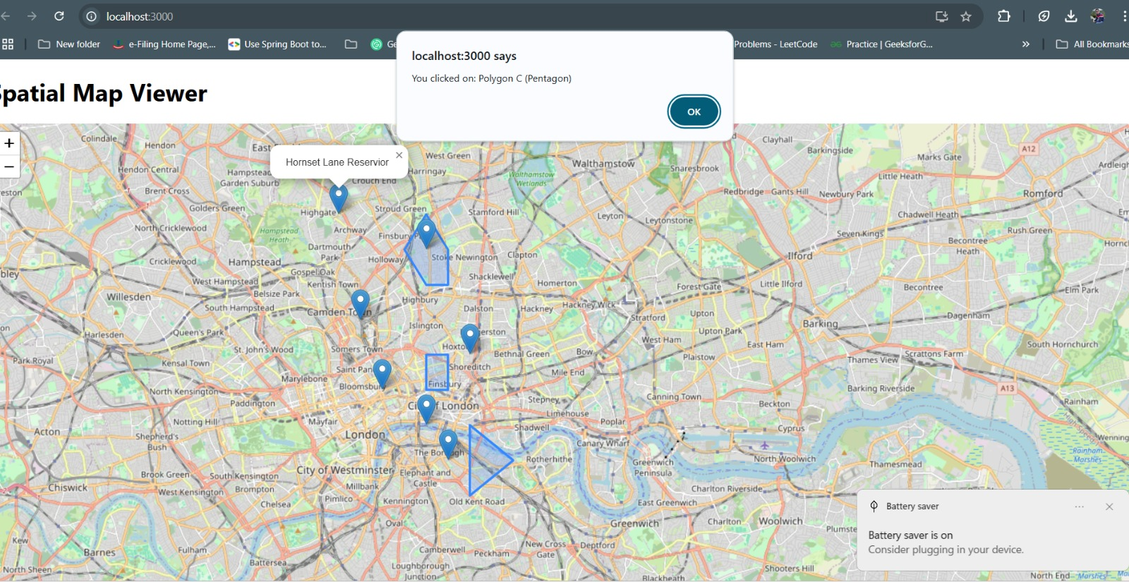

## ****Next Steps****

* • Enhance styling for better UI/UX • Optimize performance for larger datasets